ITopiaLogo

**Implementation plan**

*Project: Virtualisation*

|  |  |  |  |
| --- | --- | --- | --- |
| **Client: Plaintech** |  | **Filename:** |  |
| **Project: Virtualisation** |  | **Version:** | 0.3 |
| **Author: Willem Westerhof, Pieter Dieleman, Eddy van der Steen, Kjell Zijlemaker, Rodney Lanuzga** |  | **Date:** | 21-11-2014 |

# Documentproperties

## History

|  |  |  |  |  |
| --- | --- | --- | --- | --- |
| **Version** | **Date** | **Changes(concept/final)** | **Client** | **Author(s)** |
| 0.1 | 16-11-2014 | Translation template to english | Plaintech | Willem Westerhof |
| 0.2 | 19-11-2014 | Adding chapters to the Implementation plan | Plaintech | All teammembers |
| 0.3 | 21-11-2014 | Adding chapters to the implementation plan | Plaintech | Willem Westerhof |
|  |  |  |  |  |
|  |  |  |  |  |
|  |  |  |  |  |
|  |  |  |  |  |
|  |  |  |  |  |

## Approval

This document needs the following signatures of approval:

|  |  |  |  |  |
| --- | --- | --- | --- | --- |
| **Name** | **Role** | **Autograph** | **Document Date** | **Version** |
| Arjen Jansen | Project manager |  | 21-11-2014 | 0.3 |
| CEO/CFO | Client |  | 21-11-2014 | 0.3 |

Index

Documentproperties 2

History 2

Approval 2

1. Outcomes and end goal 4

2. MoSCoW 5

3. Project organization 6

4. Roles and responsibilities 7

5. Implementation scenario 9

5.1 Needed Third parties: 9

5.2 Services supplied by itopia: 9

5.3 Services supplied by Plaintech: 9

6. The actual Implementing 10

6.1 Global Setup 10

6.2 Place all the racks in the server room 10

6.3 Arrange the SAN rollout 10

6.4 Setup the SAN so that it is configurable 10

6.5 Place the KVM Servers 10

6.6 Install Debian on Servers 10

6.7 Run install script on servers 10

6.8 Place Plaintech internal servers on virtual machines 10

7. Implementations costs 11

8. Implementation schedule 12

9. Fallback scenario 13

# Outcomes and end goal

After the delivery and acceptance of the proof of concept the Itopia organisation will start the full scale implementation plan. The end goal of the implementation stage is virtualizing all current plaintech servers and setting up the entire new infrastructure.   
  
In order to reach this end goal a lot of work needs to get done. This amount of work is not just limited to the employees of Itopia. Some 3rd party companies will be required (building companies, cable companies etc.). In this document we will mainly focus on the role of Itopia in this process.   
  
The expected results of this project are great financial profit (see business case for exact details) as well as a better competitive position. As their current hardware setup is outdated the renewed infrastructure setup will give them a great competitive edge.

# MoSCoW

In order to fully implement this system across the entire plaintech infrastructure the following MoSCoW has been established. **Must have:**building with full hardware setup  
Customer service location and personnel  
The proof of concept  
Cooling  
Enough power supply  
Enough internet acces **Should have:**2nd building for redundancy purposes  
Space for growth  
Fire supression **Could have:**Security **Won’t have:**-

# Project organization

In the diagram below you can find the project organisation. The 3rd party box is all external parties that are required to complete the full implementation proces. Consider these people the contractor companies, real estate agents etc. The implementation stage will be monitored and controlled by the original team members of the proof of concept stage.

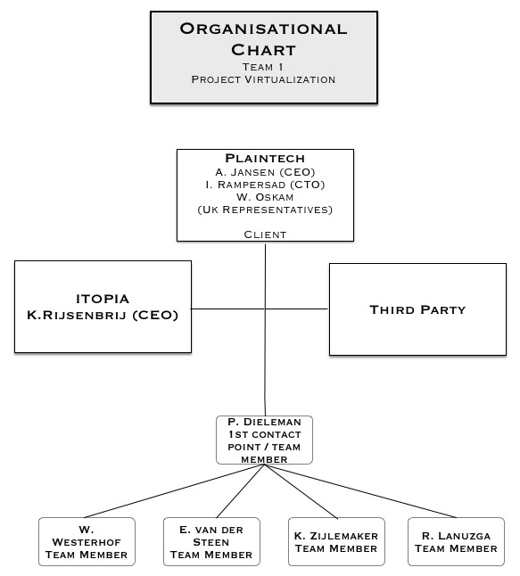

# Roles and responsibilities

***Project Team***

Our team exists out of 5 members that take full responsibility for Project virtualization. Each team member will be designated with a task that they must fulfil during the whole project. Our task is to create the full scale implementation for Plaintech.

|  |  |  |
| --- | --- | --- |
| **Team 1** |  |  |
| **Name** | **Role / Responsibility** | **Contact** |
| Pieter Dieleman | Team Member | Pieter.Dieleman@hva.nl |
| Willem Westerhof | Team Member | willem.westerhof@hva.nl |
| Kjell Zijlemaker | Team Member | Kjell.Zijlemaker@hva.nl |
| Eddy van der Steen | Team Member | Eddy.van.der.Steen@hva.nl |
| Rodney Lanuzga | Team Member | Rodney.Lanuzga@hva.nl |

The client is the head of the project and is responsible for providing us with the correct information and paying the bills needed for the implementation plan.

|  |  |  |
| --- | --- | --- |
| **Client** |  |  |
| **Name** | **Role / Responsibility** | **Contact** |
| Plaintech / A. Janssen | Client/CEO | a.jansen4@hva.nl |
| Plaintech/ W. Oskam | Client/CFO | w.oskam@hva.nl |
| Plaintech/ I. Rampersad | Client/CEO | i.m.rampersad2@hva.nl |

The project manager is responsible to report all information and progress to the client. He also gives us feedback about how to improve so we can satisfy the client.

|  |  |  |
| --- | --- | --- |
| **Project manager** |  |  |
| **Name** | **Role / Responsibility** | **Contact** |
| A. Jansen | Project manager | a.jansen4@hva.nl |

third parties will be noted here including their responsibilities. As for now these parties are yet unknown. We will find the suitable third parties after the proof of concept stage is finished.

|  |  |  |
| --- | --- | --- |
| **Third parties** |  |  |
| **Name** | **Role / Responsibility** | **Contact** |
| TBA | Example: Builders | Example@example.nl |

# Implementation scenario

Throughout the implementation stage there are quite a few things that need to be done. In this document you will find a description of what Itopia is going to do during this stage as well as a short overview of what kind of third parties we need to complete the implementation stage.

## Needed Third parties:

- Construction Company  
- Internet service provider  
- Power supplier  
- Security/safety measures  
- Real estate agent  
- Testers

## Services supplied by itopia:

- After receiving approval from plaintech we will monitor construction and third party proceedings.  
- We will gather the needed permits etc. within dutch law.  
- We will place all infrastructure.  
- We will install all system aspects.  
- We will setup a helpdesk and recruit employees for this.  
- We will make sure all of our systems are properly tested.

## Services supplied by Plaintech:

- Monetary provisions where needed.*  
- Extracting all relevant data from current system needed to implement them into the new system.  
- Notifying customers of the coming changes.  
  
*all costs not previously discussed will first be discussed by Itopia members with Plaintech CFO and CEO’s.

# The actual Implementing

## Global Setup

* Place all the racks in the server room
* Arrange the SAN rollout
* Setup the SAN so that it is configurable
* Place the KVM Servers
* install Debian on servers
* run install script on servers
* place plaintech internal servers on virtual machines

## Place all the racks in the server room

in document x there’s a map of how the racks should be placed, do this!

## Arrange the SAN rollout

Place the SAN devices in the racks

Place the FiberSwitches in the racks

Connect the SAN devices to the fiber switches

## Setup the SAN so that it is configurable

## Place the KVM Servers

Place the KVM servers

## Install Debian on Servers

## Run install script on servers

## Place Plaintech internal servers on virtual machines

# Implementations costs

*extract from business case*

# Implementation schedule

Below you will find a schedule of our approximate time schedule for the implementation plan. This schedule is based on estimates, actual timing could differ from this.

12 January 2015 Final version proof of concept   
end of January 2015 Plaintech accordance with implementation plan  
2015-2016 Planning, designing, getting permits for building etc.  
2016-2017 Construction of building including security, power etc.  
End of September 2017 Start deploying proof of concept, placing server racks.  
End of 2017 Testing if all systems are fully functional  
start 2018 moving hosts to new system.  
March 2018 Fully operational system.

# Fallback scenario

Throughout the entire implementation program the current system setup of plaintech will be up and running. Once the new environment has been tested and proved fully functional we will switch all clients to the new environment. After this switch the old environment can be shutdown, sold, etc. (what happens to the old environment is up to plaintech itself).   
  
Throughout this entire implementation stage the old environment will remain active. If for some reason the new environment is functioning incorrectly or is delayed, the old environment will simply be kept up a while longer. This does of course increase some of the costs but makes sure that none of the customers will have any problems during the implementation stage.   
  
The main goal of maintaining the old environment throughout the implementation stage is to make sure no downtime is ever forced upon the customer. It also functions as a fallback point in case something unexpected occurs. We do not expect to have any errors, but it is good to be prepared just in case.